

TENNIS COACHING PROVIDER OPPORTUNITY

Bridgend

Background
Tennis Wales is the National Governing Body of tennis in Wales, with a network of registered places to play, accredited coaches, volunteers, and competitions. As part of our ambition to transform the delivery of parks tennis in Wales, we wish to partner with various coaching providers in order to provide community coaching/activating programme to local people accessing our network of ‘Tennis Wales In The Park’ sites.

Tennis Courts in Bridgend

In our strategy for tennis opened up across Wales, we committed to transform the delivery of tennis in parks with Tennis Wales supporting sustainable park facilities and collaborating with local authorities.

We’re continuing to attract funding to invest into local park tennis facilities across Wales and are now looking for a partner to provide tennis coaching to the local communities. The parks are part of our Tennis Wales in the Park initiative, providing low-cost tennis across Wales that can all be booked and organised online.

Bridgend Parks provide a fantastic opportunity for the city to work together to grow tennis across the city. Bridgend Local Authority had a population of 139,200 – up from 128,700 in 2001. Bridgend plays host to 63 primary schools and 8 comprehensive schools, many of which are welsh language schools.

We know that more people play tennis in public parks than anywhere else in Wales, and this is an exciting opportunity for a coach / coaching team to provide accessible and affordable tennis in the local community.

Following successful introduction in other parts of the country, the sites across Bridgend have benefited from gate-access technology integrated with the ‘ClubSpark’ booking platform alongside resurfacing of the court playing area in order to have the courts available for hire and aid all year-round play.

Bridgend Coaching Provider** Opportunity

Tennis Wales is working in partnership with the Lawn Tennis Association (LTA) to:

1) Encourage local residents to either take up or play more tennis
2) Improve local tennis facilities for residents
3) Make sure local tennis courts are sustainable in the years to come.

An important aspect of the partnership is to have an effective programme of activity to engage new players and help people learn how to play the game.

As there is no current coaching programme in place, we are advertising herein for a Coaching Provider to deliver a high quality, sustainable and inclusive tennis coaching programme at the following sites; (photo’s of sites in Appendix A)

- Caedu Park
2 Outdoor Courts with gate access installation
Address: Park Ave, Ogmore Valley, Bridgend, Wales, CF32 2DH

- Heol Y Cyw
2 Outdoor Courts with gate access installation
Address: High St, Heol Y Cyw, South Wales, CF35 6HU

- Maesteg Welfare Park
3 Outdoor Courts with gate access installation
Address: Heol Ty Gwyn, Maesteg, Bridgend, CF34 0AZ

The initial contract is anticipated to be for two years, for the period of 01/07/2024 – 01/07/2026 (the commencement date is subject to works being completed on schedule and may change), with a probation period covering the first twelve months.

There will be the option to extend the contract for a further two years to 2028 (subject to review and both parties’ agreement).

Tennis Wales is inviting applications from coaching providers nationally to demonstrate how they will work in line with LTA events, develop community sporting initiatives, promote accessible coaching, and event opportunities, and work with the community to either take up or play more tennis.

Tennis Wales is committed to increasing community and inclusive tennis (most notably with increased participation) on the improved courts.

A successful and diverse coaching programme is seen as a key driver to help the Tennis Wales meet its objectives of opening up tennis across Wales.

Expectations

Focus of coaching programme:

• To develop and deliver an effective, inspiring and sustainable community tennis development programme for people of all ages and abilities (adults, juniors, minors)

• Provide attractive opportunities for casual and recreational players who perceive joining a club to be too formal for their needs to access the sport

• Support LTA initiatives where appropriate, specifically Big Tennis Weekend and other national products and / or campaigns / programmes / initiatives

• Provide periodic attendance statistics data to the LTA and the Council

• Consideration should be given as to how coaches will engage new players into tennis, particularly those classed as 'inactive' by the UK Chief Medical Officer's definition

• Participation opportunities for all who fall under the protected characteristics listed in the Equality Act 2010. This could include FREE PARKS tennis for underserved children, LGBTQ+ sessions/club, disability focused sessions etc

Support for each Site

The agreement to operate on the site will be for two years (with a 12-month review) with an option to extend at the end of that period.

The agreement is to utilise a reasonable number of court hours a week of peak court time, to develop a coaching and community programme.

Courts will be discounted for the successful coaching operator of the site and a 50% court fee applied taking it from £4.50 per hour per court to £2.25 per hour per court.

The successful provider would be expected to promote membership opportunities to customers.

Keep all income generated for their own business (pay and play and annual pass fees exempt).

Court Usage

The successful coaching provider will be entitled to use up to a maximum of 30 court hours per week for coaching. This is capped to ensure a reasonable amount of court time remains available for casual tennis bookings. Sub-letting of court time will not be permitted.

A maximum of one court can be used at any one time for coaching to ensure at least one court remains available for casual bookings (although Tennis Wales may offer some flexibility to these arrangements during quiet periods).

Additional benefits for successful coaching provider:

• Six-month advance booking window (casual bookers will be limited to seven day advance booking restrictions)

• Endorsement from Tennis Wales that the supplier is the NGB’s sole tennis coaching provider at these chosen sites

• Promotional support as necessary via the NGB’s social media handles and through our Tennis Wales in the Park newsletter to over 5,500 park players in our database

(It is expected that the successful coaching provider will provide content for these newsletters to us monthly and keep this information up to date).

Supplementary Information

The coach will be expected to hold an LTA Level three coaching qualification or above, hold and maintain LTA Coach Accreditation+, and will require a DBS check in line with the Tennis Wales Safeguarding Policy.

The coaching provider should make every effort to market and promote their own sessions, although the NGB has some capacity to provide marketing support for special events. For clarity, the provider should market themselves under their own company banner (rather than the NGB’s).

The coaching provider will not be expected to deliver any court maintenance (this will be delivered by Tennis Wales, independently sought maintenance companies or the Vale of Glamorgan Council) other than assisting in keeping the courts clean and tidy, assisting with risk assessment checks and raising issues and concerns promptly with Tennis Wales.

The coaching provider will be requested to assist with national engagement campaigns such as Big Tennis Weekend (BTW) and the FREE PARKS TENNIS programme.

Person / Organisation Specification

The successful coaching provider will have:

• A programme delivered/overseen by an LTA accredited+ coach, qualified at a minimum of level 3

• Hold and maintain during the entirety of the relationship current LTA Coach Accreditation+

• Experience in providing community-focused tennis activities and an understanding of how to address barriers to participation

• Recently attended or be willing to attend training on coaching people with disabilities and/or impairments

• Observation of LTA minimum standard in coach and other staff qualifications/training, safeguarding (including DBS checks) and equality of opportunity

• The ability to provide an ongoing risk assessment covering activities

• Relevant insurances in place to cover all activities undertaken on the site; coaching, events and any others that arise

• A GDPR policy and method statement about managing player data

• The ability to be flexible when required

• Competent IT skills (MS Office/internet)

• A current DBS check.

If you, or someone you know is interested, the form of tender for completion is below, along with the tender timetable.

Please ensure you have read and understood the terms and conditions contained within this application pack before completing the tender form.

Tender Application for the right to provide tennis coaching provision under agreement for up to a maximum of 30 court hours in total per week, and a maximum of two courts at any one time***

IMPORTANT: Please read the Terms and Conditions included within this application, before completing the form.

Tender Timetable

Deadline for tender return | 18th Aug 2024
Interviews Week Commencing (If needed) | 19th Aug 2024
Tender Awarded By | 23rd Aug 2024
Contract Start | 26th Aug 2024

Park site you are applying for | Tick the appropriate site/s 
Caedu Park
Heol Y Cyw
Maesteg Welfare Park

1 | Name of Applicant
2 | Address
3 | Telephone
4 | Email
Tender Response Quality Questions (please continue each item on a clearly marked separate page if needed)
5 | LTA Coach Accredited+ and LTA Qualified at Level 3 or above? Please state what level
6 | A short summary of why you are interested in this project
7 | Outline your experience and success in providing community -focused tennis programmes and initiatives. Note - Your answer should include examples and reference to partners you have worked with
8 | Please demonstrate your understanding of how to address barriers to participation, detailing any relevant experience, including any recent courses
9 | Outline what programmes you intend developing within three months of contract start to a) encourage local residents to either take up or play more tennis, and b) breakdown participation barriers Note - Your answer should include reference to the marketing strategy you will adopt and may include references to seasonal programming variations
10 | Describe how you will integrate healthy competition into your coaching programme e.g Will you utilise the LTA’s Team Challenge resource packs and use them as a retention tool but also promotion of competition opportunities.
11 | How you will provide an ongoing risk assessment covering activities
12 | Outline of your GDPR policy and method statement about managing player data
13 | Competent IT skills (MS Office/internet)
14 | DBS checked?
15 | Are there any other notes you would like us to take into consideration with your tender?
16 | Two suitable references that are happy to be contacted in relation to your business skills, character and coaching provision
Tender Response Evidence Based Questions
17 | Please separately provide your Business Plan, or statement, of how you will operate the coaching programme. Please be aware these are community tennis courts, and coaching fees should reflect this. To assist you, the Business Plan should include the following headings; Objectives, Tennis Development Plan, Management and Staffing Arrangements, Marketing Plan, Financial Plan (to include Charging Rates for coaching and events (such as summer camps) and Management Strategy, Monitoring and Evaluation, Conclusion). For information purposes rates are set out as defined in the STC Rates Table (Appendix A)
18 | Please attach a CV/resume demonstrating your experience of managing a coaching programme
19 | Copies of relevant certificates (including insurance policy)

Form of Tender:

I/We understand that I/we offer for two years with an option to extend to another two years.

Terms and Conditions

The coach provider shall observe and perform the following conditions and stipulations and any other conditions which the NGB may subsequently require.

1. The agreement start date is proposed for 26th Aug 2024.

2. Tennis Wales shall be responsible for the payments for pay and play usage and annual passes sold in order to create sinking funds for the TWITP network of park sites.

3. Service, maintenance of fence, gates, floodlights, structure, nets, and posts are Tennis Wales’s provision, through communication with Licensee. Issues should be reported immediately to stuart.baker@tenniswales.org.uk.

4. Court treatments to be provided by Tennis Wales or an external contractor, communicated and arranged at suitable times with the Licensee.

5. Tennis Wales will be responsible for the court booking system CLUBSPARK and associated booking and membership/annual pass management.

6. Tennis Wales will be responsible for Venue Registration with the LTA.

7. The coaching provision will have an LTA accredited+ coach, qualified at a minimum of level 3, experienced in providing community-focused tennis and trained or willing to train on coaching people with disabilities. Coaching provider/s will be DBS checked. Coaching provision will be for no more than 30 court hours per week (capped to ensure that a reasonable amount of court time remains available for casual tennis bookings). The focus of the coaching programme will be:

• To develop and deliver an effective, inspiring, and sustainable community tennis development programme for people of all ages and abilities (adults, juniors, minis).

• Provide attractive opportunities for casual and recreational players who perceive joining a club to be too formal for their needs to access the sport.

• Support LTA initiatives where appropriate, specifically Great British Tennis Weekend and other national products and / or campaigns.

• Provide periodic attendance statistics data to the LTA and the Council.

• Consideration should be given as to how coaches will engage new players into tennis, particularly those classed as 'inactive' by the UK Chief Medical Officer's definition.

• Provision for players with disabilities and/or impairments must feature in programme (e.g. Wheelchair Tennis).

8. Tennis Wales shall ensure that the courts are accessible for use by those with a season ticket or pay and play booking on other court/s whilst coaching during between the hours of 8:00am and 9:00pm during the term of the agreement, unless a specific arrangement for solo use is made with Tennis Wales for specific dates or times.

9. The coach provider to sign within 14 days of the acceptance of the tender by the NGB.

10. Tennis Wales will authorise the coach provider to provide exclusive coaching provision at the courts.

11. The coach provider shall hold the NGB’s indemnified from and against all actions, costs, damages, claims and demands whatsoever and shall insure the coaching provision provided by the coach provider against any damage, loss or injury which may occur to any property or to any person by or arising out of the exercise of the rights conferred by the agreement and the coach provider shall whenever required produce to Tennis Wales the Policy or Policies of insurance and the receipts for the payment of the current premiums. Such insurance shall provide cover for a minimum of £10,000,000.

12. The coach provider and all of their employees shall be of good behaviour on site and maintain a suitable standard of customer service and presentation at all times.

13. The coach provider is to carry out a visual risk assessment when going onto court to make sure there are no dangers before going on court e.g., broken glass.

14. The coach provider shall ensure that any near miss or accident is reported to Tennis Wales within an hour of its occurrence with a full incident and, if applicable, a copy of the RIDDOR report provided within 24 hours. The Licensee shall ensure that these records include details of any relevant actions taken/to be taken and shall be available to Tennis Wales at any time.

15. The coach provider shall enforce the legislation relating to smoking in public places. The following hygiene and safety standards and rules must be maintained and enforced within the facility by the coach provider as follows:

- No person is allowed to enter the facility who:
- is under the influence of alcohol or drugs
- is considered to be a risk to themselves or others
- No inappropriate footwear likely to cause damage to court surfaces is allowed;
- No animals or pets are allowed within the Facilities with the exception of guide dogs for the blind and recognised assistance dogs;
- No persons are permitted to skateboard, roller skate, or alike or to partake in activity sports such as BMX cycling or motorised vehicle sports within the facilities.

16. The coach provider shall carry out weekly risk assessments for the facilities, which will be included in the Health and Safety Procedures Manual and available for Tennis Wales to review upon request. The Partner shall revise them as a minimum:

- If there is an accident or incident where a change is required to prevent a recurrence.
- If a new task (for staff) or activity (for members of the public) is introduced where a new risk assessment is required before commencement
- Before and after a new item of equipment is purchased (excluding identical replacement items); or
- If a change to the building or premises is planned where new / revised arrangements for its safe use will be needed.

17. Tennis Wales shall not be responsible for any death, injury, damage, or loss sustained by the coach provider resulting from storm, high seas, tempest, pandemics, or any other cause whatsoever except where such death or personal injury is caused by the negligence of the NGB.

18. Tennis Wales shall not be liable for any other loss or damage sustained by the coach provider resulting from storm, high seas, tempest, pandemics, or another cause whatsoever in connection with this Licence or for the condition of the site.

19. The coach provider shall not do or permit to be done in or upon the courts or any part thereof or in the vicinity thereof anything which in the opinion of Tennis Wales is or may become a nuisance or annoyance to public.

20. The coach provider will maintain a high standard of presentation of the courts used for coaching at all times when coaching on site.

21. The coach provider is responsible for the cleanliness of the site where coaching is being provided and shall at all times keep the site free from litter resulting from the exercise of rights conferred by this agreement.

22. Tennis Wales may by seven days’ notice in writing revoke the agreement if at any time there shall be a breach of any of the conditions but without prejudice to the Council’s rights and remedies in respect of such breach.

23. The coach provider shall on the termination of the agreement leave the courts in a clean and tidy condition.

24. No vehicle shall be driven on to the site other than for the express purpose of delivery of goods to the courts and shall be removed from the site immediately after the unloading of goods.

25. No vehicle of any description will be positioned or left unattended so to impede the access of any emergency services or maintenance teams. Where access is required, this must be accommodated in all cases.

26. Tennis Wales is not bound to accept any offer.

27. I agree to comply with and abide by the Tender’s Terms and Conditions as signed below.

Name: (Please print):……………………………………………………

Company Address:

Signed: …………………………………………………………

Dated: ……………………………

Tender applications are to be emailed to stuart.baker@tenniswales.org.uk detailing the information set out above, or posted to Tennis Wales Ltd. Office 10, House 3, Ground Floor, The Maltings, East Tyndall Street, Cardiff, CF24 5EZ.

Any queries can be addressed to the Tennis Wales staff member stuart.baker@tenniswales.org.uk

Please refer to Tennis Wales’s Document Retention Policy and Data Protection Policy for details on retention and handling of tender documents and any personal data within.

* All references to the start date may change in line with the completion of the courts etc.

** For the purposes of this document a ‘coaching provider’ is defined as an organisation or coach that systematically organises tennis activity for the benefit of multiple players.

*** The NGB may offer some flexibility to these arrangements during quiet periods.

Note: Information was correct as of July 29th 2024

APPENDIX A – Photo’s of Bridgend Park Tennis sites out for tender

Caedu Park
2 Outdoor Courts with gate access installation
Address: Park Ave, Ogmore Valley, Bridgend, Wales, CF32 2DH

Heol Y Cyw
2 Outdoor Courts with gate access installation
Address: High St, Heol Y Cyw, South Wales, CF35 6HU
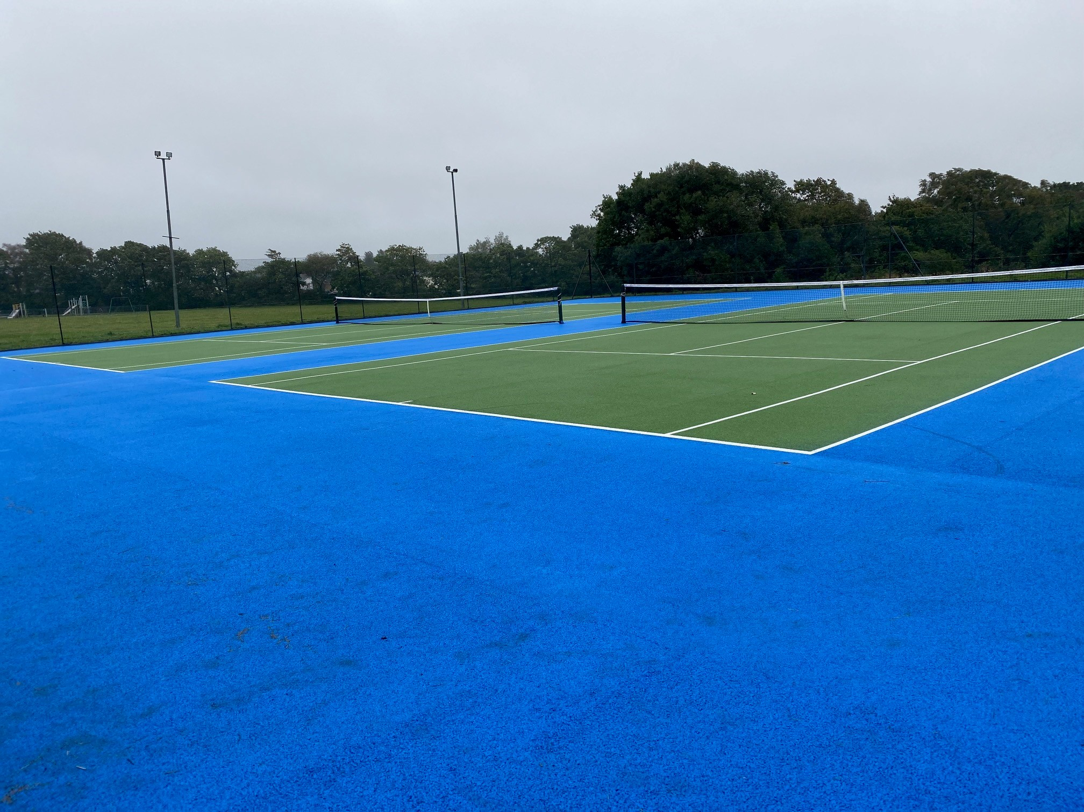

Maesteg Welfare Park
3 Outdoor Courts with gate access installation
Address: Heol Ty Gwyn, Maesteg, Bridgend, CF34 0AZ


